04 August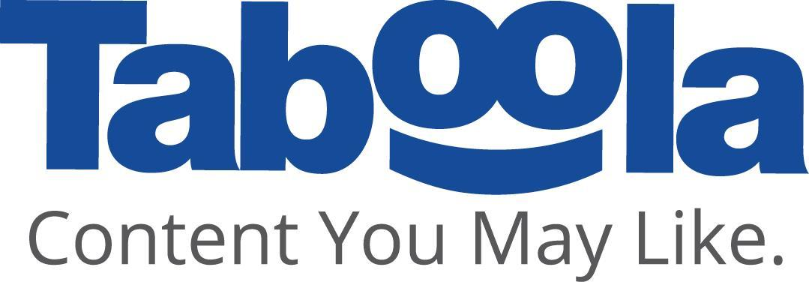 2025

Hey Ohad,

Before we part ways, we just wanted to make sure you have all the information you need.

Your last salary will be paid in **October** and will include redemption of all unused accrued vacation and recreation pay, if relevant. If you have any questions in this regard please contact Nela Tsehansky from the finance team (email: nela.t@taboola.com 052-3776903). Within 15 days following the payment of your last paycheck, Nela would send your personal email the last payslip and letters of release with respect to the amounts (severance pay and pension) accrued under your managers’ insurance policy and/or your pension fund. We encourage you to download from “Hilanet” form 106 and copies of your pay slips prior to your last day at the company.

Questions related to your insurance can be directed to Amir Izac (amir.izac@agamin.co.il ,052-3776903).

Please don’t forget to return any document, object or equipment which belongs to Taboola and which is in your possession such as IT equipment (phone, computer, mouse, keyboard etc.), WFH equipment (chair, screen, camera etc.) **before your last day**. Additionally, if you have a Taboola cellular line please don’t forget to migrate your line before your departure. Also delete from your personal computer any software and/or data that is related, by any way, to Taboola or to your employment with Taboola. In addition, be mindful of your obligations towards Taboola, which continue to apply, even after termination of our relationship, such as non-compete, intellectual property undertaking and confidentiality obligations. Please note, you are expected to return all equipment before your last day. Not returning Taboola’s equipment on time will cause complications with your off-boarding process.

With respect to any stock options and/or RSUs, on your last day of employment any unvested units (whether RSUs or options) will be forfeited. Any vested RSUs belong to you and you can hold them as long as you want. **Important:** **If you’ve been given an option grant, you are entitled to exercise your vested options within 90 days after your Termination Date. If you do not exercise them during that time period, they will expire and be forfeited.**  *Note that the process of exercising options takes a few days, therefore we strongly recommend that you do not to wait until your last day to exercise your options (i.e., last of the third month from your termination date) or you risk them expiring*. It is important to start the process of exercising your vested options as soon as possible following the termination of your employment.

To check your award(s), please visit our online options platform at<https://capitalnew.ibi.co.il/account>. If you have not already registered for this platform, or if you have questions about the process of exercising your vested options, please contact the IBI help desk.

Here are the ways to contact them:

● International telephone: +972-3-684-9282

● US telephone: +1-917-284-9576

● Thailand telephone: +66-25660309

● India telephone: +91-8009190255

● Whatsapp text: +972-3-684-9282

● Email: sop@ibi.co.il

Hours of operation:

● Sun : 2:00am – 9:00am (NY time) / 9:00am – 4:00pm (Israel time)

● Mon – Fri: 2:30am – 4:00pm (NY time) / 9:30 am – 11:00 pm (Israel time)

Please note that after your departure from Taboola, you will have access to your account at IBI indefinitely. Since your Taboola email won’t be available after your departure, please make sure to update your user name to your personal email address. You can make that update by contacting the IBI help desk.

Trading windows – If you are leaving your employment with Taboola once the trading window closes, then you will not be able to trade your TBLA shares until Taboola’s trading window is reopened.   
If you are leaving your employment with Taboola during an open window, then you are no longer subject to Taboola’s trading windows.   
For purposes of trading, a person's last day of employment is the day they are no longer reflected on Taboola payroll and not a person’s last day in the office.

If you have more questions about the process, please contact the Stock Administrator at options@taboola.com

Best of luck to you!